Telusko: Advance Java 08

191 aop and writing point cut expression

1.Aspect
2.Advice
3.PointCut
4.JoinPoint
5.Target
6.Weaving
7.Proxy
Annotations
===========
1.@Aspect
3.@PointCut
2.@Before,@After,@Around,@AfterReturning,@AfterThrowing
=>@PointCut("execution(""))
PointCut
========
It is an Expression which selects Buisness class methods which needs advices.
PointCut can never specify which Advice is going to be selected.
Pointcut Syntax
===============
Specifier ReturnType package.ClassName.methodName(parameterType)
Note: Symbols allowed in PointCut Expression : .(dot),*(star)
Examples
1. public int in.ineuron.dao.EmployeeDao.saveEmployee(Employee)
saveEmployee() method having parameter Employee with return type 'int' of
type public defined inside a class EmployeeDao(in.ineuron.Dao)
is selected to connect with Advice.
2. public int in.ineuron.dao.EmployeeDao.*()
=> Zero parameter
=> Any methodName/Method inside EmployeeDao
=> int return type
3. public * in.ineuron.dao.EmployeeDao.*(..)
=> Any no of parameter
=> Any methodName/Method inside EmployeeDao
=> Any return type
4. public * in.ineuron.dao.*.*()
=> All classes present in in.ineuron.dao packages and there methods which
accepts zero argument and method can have any return anytype.
B.Methods
=========
M#1 public int saveEmployee(Employee emp){}
M#2 public void deleteEmployee(Integer eid){}
M#3 public void updateEmployee(Employee emp){}
M#4 public Employee getEmployee(Integer eid){}
PointCut Expressions
====================
a. public * *()
[Zero params, any parameter any return type]No of methods matching => zero
b. public void *(..)
[Any no of params,and return type is void]
No of methods matching(2) => M#2,M#3
c. public * saveEmployee(..)
[Any no of params, and return type]
No of methods matching(1) => M#1
d. public * *(Integer)
[Only one param and can have any return type]
No of methods matching(1) => M#4
Note:: * in the return type doesn't select a method with void return type.
Usage of AOP in realtime environment
====================================
interface EmployeeRepository extends CrudRepository<Employee,Long>{}
@Service
public class EmployeeServiceMgmtImpl implements IEmployeeService{
@Transactional
public void saveEmployee(Employee){}
}
Case2: If exception occurs in buisness method and if that exception information has
to be known by Advices then we need to use
EmployeeDao.java
================
@Component
public class EmployeeDao {
public void saveEmployee() {
System.out.println("Employee saved to database....");
if (new Random().nextInt(15)<10) {
throw new RuntimeException("DUMMY EXCEPTION");
}
}
}
TransactionManagement.java
==========================
@Aspect
@Component
public class TransactionManagement {
@Pointcut("execution(public * in.ineuron.dao.*.*(..))")
public void p1() {}
@AfterThrowing(value = "p1()",throwing = "exception")
public void rollBackTx(Throwable exception) {
System.out.println("Transaction rollbacked:: "+exception.getMessage());
}
}Case3: If there is a return type in buisness method and if that returned value has
to be known by Advices then we need to use
EmployeeDao.java
================
@Component
public class EmployeeDao {
public String saveEmployee() {
System.out.println("Employee saved to database....");
return "Hello";
}
}
TransactionManagement.java
==========================
@Aspect
@Component
public class TransactionManagement {
@Pointcut("execution(public * in.ineuron.dao.*.*(..))")
public void p1() {}
@AfterReturning(value="p1()",returning = "obj")
public void commitTx(Object obj) {
System.out.println("Transaction commited..."+ obj);
}
}

192 SpringRest using @RequestParam and ResponseEntity<T>
SpringRest
==========
JSON :: JavaScript Object Notation
=> It is a way of representing the Object using key:value format
=> Key must be represented in "" and value can be anything, if the value is in
String format then also it should be in "".
=> One {} bracket indicates one Object or sub Object
=> [] represents array/list/set elements values
=> In Json Array/list/set collection will be treated as array only.
=> In Json Array/list/collection are called "1-D" array.
=> In Json Map collection is called "2-D" array.
=> In Json Map collection elements and HAS-A property elements will be represented
using sub/object node
{"Key":"value", "key": "value",.....}
Java
====
Customer customer = new Customer(10,"sachin","IND",53.4f);
JSON(light weight)
==================
{
"cno": 10,
"cname" : "sachin",
"country": "IND",
"Avg": 53.4
}
XML(Heavy weight)
=================
<customer>
<cno>10</cno>
<cname>sachin</cname>
<country>IND</country>
<avg>53.4</avg>
</customer>
What is the difference b/w HTML and JSON?
HTML/CSS => It is given to display data on browser by applying styles
JSON/XML => It is given to describe data(To construct data having structures)
To convert the data from Json/Java or from Java/JSON we take the help of api called
"Jackson" api.
1.jackson-databind
<dependency>
<groupId>com.fasterxml.jackson.core</groupId>
<artifactId>jackson-databind</artifactId>
<version>2.14.2</version>
</dependency>
sample-lite.json
================
{
"id": 10,
"firstName": "Sachin","lastName": "Tendulkar",
"active": true
}
public class TestApp {
public static void main(String[] args) {
try {
// Create Object Mapper
ObjectMapper mapper = new ObjectMapper();
// using that Object read the data from json file and convert
into pojo object
Customer customer = mapper.readValue(new File("data/sample-
lite.json"), Customer.class);
System.out.println(customer);
} catch (IOException e) {
// TODO Auto-generated catch block
e.printStackTrace();
}
}
}
Note::
To convert JSON to POJO Object internally jackson-api calls "setXXXX()" and binds
the value to java Properties.
{
"id" : 10 ===setXXXX()=====> setId(10)
}
To Convert Pojo to JSON, internally jackson-api calls "getXXXX()" and binds to Json
Object(K,V)
Customer customer = new Customer("sachin");
customer.getXXXX()
|
|
|
|
{
"name":"sachin"
}
ComplexJson Object[ Array, HAS-A property]
==========================================
{
"id": 10,
"firstName": "Sachin",
"lastName": "Tendulkar",
"active": true,
"address": {
"street": "25/1",
"city": "Mumbai",
"state": "Maharashtra",
"zip": "560026",
"country": "IND"
},
"languages" : ["Java", "C#", "Python", "Javascript"],
"Company" : "MI"
}@Data
@JsonIgnoreProperties(ignoreUnknown = true) //Any unknown properties coming into
java object for binding to ignore we use the annotation
public class Customer {
private Integer id;
private String firstName;
private String lastName;
private Boolean active;
// HAS-A property
private Address address;
// Array property
private String[] languages;
}
Sending the response from the application as JSON
=================================================
@Data
public class Product {
private Integer pid;
private String pname;
private Double price;
private String[] types;
}
TestApp.java
============
public class TestApp {
public static void main(String[] args) {
try {
// Create Object Mapper
ObjectMapper mapper = new ObjectMapper();
Product product = new Product();
product = getObjectData(product);
System.out.println("In java format :: "+product);
//Converting java object into JsonString
String jsonData = mapper.writeValueAsString(product);
System.out.println("In json format :: "+product);
// Writing the data to json file
mapper.writeValue(new File("product-list.json"), product);
System.out.println("Wrote the data to json file");
} catch (Exception e) {
e.printStackTrace();
}
}
public static Product getObjectData(Product product) {
product.setPid(10);
product.setPname("fossil");
product.setPrice(24556.0);
product.setTypes(new String[]
{"chronography","simpledial","automatic"});return product;
}
}
In java format :: Product(pid=10, pname=fossil, price=24556.0, types=[chronography,
simpledial, automatic])
In json format :: {"pid":10,"pname":"fossil","price":24556.0,"types":
["chronography","simpledial","automatic"]}
wrote the data to json file
product-list.json
=================
{"pid":10,"pname":"fossil","price":24556.0,"types":
["chronography","simpledial","automatic"]}
Note::
In realtime coding/projectcoding convertion of json-pojo and pojo-json would be a
boiler plate code,so to avoid this boiler plate
code we need to use "Spring-Rest" module which takes care of all these internal
conversions.
Syntax::
@RestController
@RequestMapping("/api/customer")
public class CustomerController{
@GetMapping("/id/{theId}")
public ResponseEntity<Customer> getCustomerById(@PathVariable("theId")
Integer id){
;;;;;;
return new
ResponseEntity<Customer>(customer,HttpStatus.OK);
}
customer){
@Postmapping("/save")
public ResponseEntity<String> saveCustomer(@RequestBody Customer
;;;;;;
return new ResponseEntity<String>(body,HttpStatus.OK);
}
}
Working with RestApi to send Json as the response
=================================================
@Data
public class Customer {
private Integer cno;
private String cname;
private Float billAmount;
private String[] teamNames;
private List<String> studies;
private Set<Long> phoneNumbers;
public Map<String,Object> idDetails;
public Company company;
}
@Data
@AllArgsConstructor@NoArgsConstructor
public class Company {
private String cname;
private String ctype;
private String cddress;
private Integer size;
}
@RestController
@RequestMapping("/api/customer")
public class CustomerController {
@GetMapping("/report/{id}")
public ResponseEntity<Customer> showAllCustomer(@PathVariable Integer id) {
// get from database
System.out.println("Customer data for the id :: " + id);
Customer customer = new Customer();
customer.setCno(id);
customer.setCname("sachin");
customer.setBillAmount(54.5f);
customer.setTeamNames(new String[] { "IND", "MI", "AsiaXI",
"Mumbai" });
customer.setStudies(List.of("10th", "12th", "Engineering"));
customer.setPhoneNumbers(Set.of(9994445556L, 994349845L, 98765678L));
customer.setIdDetails(Map.of("adhar", 99453123432L, "panNo",
"DOOPQRCL12"));
customer.setCompany(new Company("MI", "IPL", "Mumbai", 45));
ResponseEntity<Customer> entity = new
ResponseEntity<Customer>(customer, HttpStatus.OK);
return entity;
}
}
Output
======
{
"cno": 10,
"cname": "sachin",
"billAmount": 54.5,
"teamNames": [
"IND",
"MI",
"AsiaXI",
"Mumbai"
],
"studies": [
"10th",
"12th",
"Engineering"
],
"phoneNumbers": [
98765678,994349845,
9994445556
],
"idDetails": {
"panNo": "DOOPQRCL12",
"adhar": 99453123432
},
"company": {
"cname": "MI",
"ctype": "IPL",
"cddress": "Mumbai",
"size": 45
}
}
@PostMapping(value= "/save")
public ResponseEntity<String> saveCustomer(@RequestBody Customer customer) {
System.out.println(customer);
Integer id = 10;
String body = "customer registered with the id :: " + id;
return new ResponseEntity<String>(body, HttpStatus.OK);
}

193 SpringRest TicketManagementApp using SpringRest,testing with Postman tool and Workign with GlobalExcpetionhandler

Annotations support
===================
1. @RestController(@Controller+@ResponseBody)
2. @RequestBody
3. @RequestParam
4. @PathVariable
5. @RequestMapping
6. @GetMapping
7. @PostMapping
8. @PutMapping
9. @PatchMapping
10.@DeleteMapping
11.@RestControllerAdvice
12.@ExceptionHandler
13.@Service
14.@Component
15.@Repository
16.@Transactional
Usage of DEV-tools
==================
=> It informs SpringBoot container to automatically reload the applications when
changes are made in the project.
<dependency>
<groupId>org.springframework.boot</groupId>
<artifactId>spring-boot-devtools</artifactId>
</dependency>
Code of Reading the record
==========================
public class TouristNotFoundException extends RuntimeException {
private static final long serialVersionUID = 1L;
public TouristNotFoundException(String message) {
super(message);
}
}
Servicelayer
============
Optional<Tourist> optional = repo.findById(id);
if (optional.isPresent()) {
return optional.get();
} else {
throw new TouristNotFoundException(" tourist with id "+id+" not found");
}
or
return repo.findById(id)
id + " not found"));
.orElseThrow(() -> new TouristNotFoundException("tourist with id :: " +
refer:: SpringRest-06-TicketManagementApp
SpringRest/SpringMVC is having PreDefined Controller to handle theExceptions/HttpErrors which is gives default whitelable error pages.
ErrorController(I)
|
AbstractController(C)
|
BasicErrorController(C)
|=> errorHtml(,,,) :: ModelAndView
|=> error() :: ResponseEntity<T>
SpringBootMVC
============
@RequestMapping(produces = MediaType.TEXT_HTML_VALUE)
public ModelAndView errorHtml(HttpServletRequest request, HttpServletResponse
response) {
HttpStatus status = getStatus(request);
Map<String, Object> model =
Collections.unmodifiableMap(getErrorAttributes(request,
getErrorAttributeOptions(request, MediaType.TEXT_HTML)));
response.setStatus(status.value());
ModelAndView modelAndView = resolveErrorView(request, response, status,
model);
return (modelAndView != null) ? modelAndView : new ModelAndView("error",
model);
}
SpringBootRest
==============
@RequestMapping
public ResponseEntity<Map<String, Object>> error(HttpServletRequest request) {
HttpStatus status = getStatus(request);
if (status == HttpStatus.NO_CONTENT) {
return new ResponseEntity<>(status);
}
Map<String, Object> body = getErrorAttributes(request,
getErrorAttributeOptions(request, MediaType.ALL));
return new ResponseEntity<>(body, status);
}
Note::
@RestControllerAdvice =>@ControllerAdvice+@ReponseBody+@Component
GlobalExceptionHandler in SpringRest
====================================
@RestControllerAdvice
public class TouristErrorControllerAdvice {
@ExceptionHandler(TouristNotFoundException.class)
public ResponseEntity<ErrorDetails>
handleTouristNotFound(TouristNotFoundException tf) {
System.out.println("TouristErrorControllerAdvice.handleTouristNotFound()");
ErrorDetails details = new ErrorDetails(LocalDateTime.now(),
tf.getMessage(), "404-NotFound");
return new ResponseEntity<ErrorDetails>(details, HttpStatus.NOT_FOUND);
}@ExceptionHandler(Exception.class)
public ResponseEntity<ErrorDetails> handleAllProblems(Exception e) {
System.out.println("TouristErrorControllerAdvice.handleAllProblems()");
ErrorDetails details = new ErrorDetails(LocalDateTime.now(),
e.getMessage(), "Problem in exeuction");
return new ResponseEntity<ErrorDetails>(details,
HttpStatus.INTERNAL_SERVER_ERROR);
}
}
refer:: SpringRest-07-TicketManagementAppErrorResponseApp
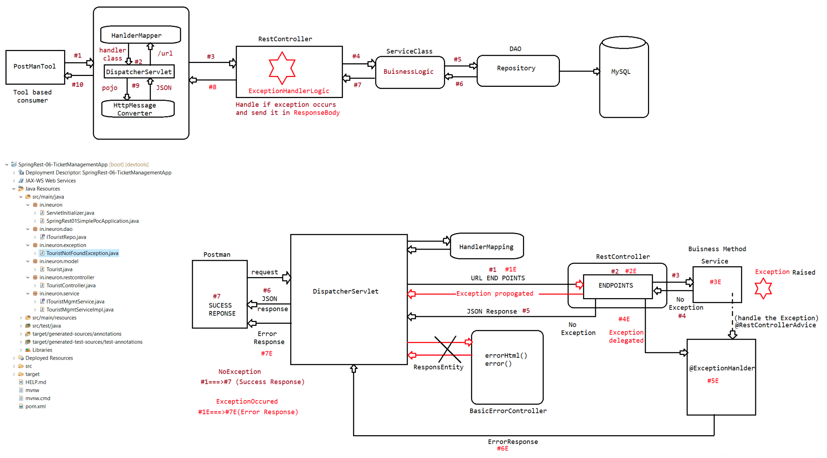

195 Integration of swagger, Working with RestTemplate(Sending differnt type of response)

SpringRest
==========
Hanlding Exception in SpringRest(GlobalExceptionHandling)
To handle the exception Globally in SpringRest we use the following annotations
a. @RestControllerAdvice
b. @ExceptioniHandler
c. Return Type of the method should be public ResponseEntity<ErrorEntity>.
APICreation/Development
=======================
Developing RestController having different methods/opertios for various
httpmethods like
a. GET b. POST c. PATCH d. PUT e. DELETE
is called APICreation/Devleopment.
=> We can generatlly take one @RestController per 1 module, so developing each
RestController is called "APICreation".
Accounts Module Creation.
Creation.
=> AccountsController(@RestController) is called AccountsAPI
TransactionModule => TransactionController(@RestController) is called TransctionAPI
Note::
API(Corejava,AdvancedJava,Framework like hiberante,spring,springboot)
Collection of .class file zipped in the form of jar and given to the endusers
RestAPI(Generating the RestEndPoints to establish cross communication b/w 2
programms where programms can be of same
language/different langauge)
EndPoints:: Providing mulitple details or collection of details that is required to
call methods/operations of RestController from ClientApp
or to send the request from different tools like POSTMAN is called
"ENDPOINTS".
eg:: AccountController nothing but AccountAPI then the endpoints
are
BASEURL :: http:://lh:9999/RestProj/api/accounts
register() :: /register -> POST
findById() :: /find/{id} -> GET
deleteById() :: /delete/{id} ->DELETE
In EndPoints of any API, we need to provide multiple details like
URL,,methodNames,requestpath,httpmethod types, content type and etc...
refer:: .png image
API Documentation
=================
=> We can write documentationfor java classes in mulitple ways
a. Using seperate text docs
b. Using API documentation comments and javadoc tool
1.
/* text */The compiler ignores everything from /* to */.
2.
//text
The compiler ignores everything from // to the end of the line.
3
/** documentation */
This is a documentation comment and in general its called doc comment. The
JDK javadoc tool uses doc comments when preparing automatically generated
documentation.
Note: Both these approaches are non-responsive documentation.we can read about the
java class/methods but we cannot test the immediately.
After developing REST apis we can provide API documentation for RestAPI in the
following ways
a. Using seperate text docs
b. Using API documentation comments and javadoc tool
c. Using Swagger/Swagger API(Creates Responsive API Documentation)
d. OpenAPI(it is an alternative to Swagger,but still comapnies are using
Swagger only)
SwaggerAPI
==========
=> It is an open source thirdparty library to provide Responsive API
documentation for RestController and its methods
=> For All RestControllers of the project we can create API documentation from
Single place while working swagger api
=> Responsive Documentation means not only we get docs about API and its
methods(EndPoints) we can test immediately by providing inputs
and getting outputs.
=> It this is used POSTMAN tool is not needed seperately and it is alos useful
to provide documentation based TestingEnvironemnt.
=> SpringFox+Swagger together released libraries that are required to use
swagger in "SpringBoot Application".
Swagger Documentation provides the following details
a. API info(company,title,license url,....)
b. End Points Info
c. Model class info
;;;
=> While working with Swagger documentation for reading and testing we need not
remember and give URL,HttpMethods types,contenttype and etc.
we just need to give inputs and get the ouptus from the Application.
Procedure to work with Swagger api
=================================
1. Keep RestController/RestAPI project ready
2. Add the following two jars in pom.xml file related to swagger api
a. Springfox-swagger2
b. springfor-swagger-ui
<!-- https://mvnrepository.com/artifact/io.springfox/springfox-swagger2 -->
<dependency>
<groupId>io.springfox</groupId><artifactId>springfox-swagger2</artifactId>
<version>2.9.2</version>
</dependency>
<!-- https://mvnrepository.com/artifact/io.springfox/springfox-swagger-ui -->
<dependency>
<groupId>io.springfox</groupId>
<artifactId>springfox-swagger-ui</artifactId>
<version>2.9.2</version>
</dependency>
3. Develops seperate Configuration class enbaling Swagger api
=> Create a Docket object having
a. Documentation type
b. specificying the base package of restcontroller
c. specifying the requestpath info
d. other details of API(AP info object having
companyname,license url,...)
@Configuration
@EnableSwagger2
public class SwaggerDocsConfig {
@Bean
public Docket createDocket() {
return new Docket(DocumentationType.SWAGGER_2)// UI Screen type
.select() // to specify RestControllers
.apis(RequestHandlerSelectors.basePackage("in.ineuron.restc
ontroller"))// base packages for// RestController
.paths(PathSelectors.regex("/api/tourist.*"))// To specify
the request paths
.build()// build the docket object
.useDefaultResponseMessages(true)
.apiInfo(getApiInfo());
}
private ApiInfo getApiInfo() {
Contact contact = new Contact("nitin", "http://www.ineuron.ai/course",
"nitin@ineuron.ai@gmail.com");
return new ApiInfo("TouristInfo",
"Gives information about tourist activities",
"3.4.RELEASE",
"http:www.hcl.com/license",
contact,
"GNU PUBLIC",
"http://apache.org/license/guru",
Collections.emptyList());
}
}
specify this key in application.properties
==========================================
#Configuring the information about swagger to display the matching expression
spring.mvc.pathmatch.matching-strategy = ANT_PATH_MATCHER
Send the request to the following url to get the swagger ui
http://localhost:9999/RestMiniProject/swagger-ui.html@ApiOperation :: It can be applied on the RestAPI/Controller methods to provider
our choice description and that reflects in swagger docs.
Eg::
@RestController
@RequestMapping("/api/tourist")
public class TouristController {
@Autowired
private ITouristMgmtService service;
@PostMapping("/register")
@ApiOperation("For Tourist Registration")
public ResponseEntity<String> enrollTourist(@RequestBody Tourist tourist) {
String resultMsg = service.registerTourist(tourist);
return new ResponseEntity<String>(resultMsg, HttpStatus.OK);
}
}
refer :: .png
Developing Consumer App using RestTemplate
==========================================
=> it alllows to devleop to Consumer/ClientApp RestFulWebService as a Programable
client in java environment.
=> We need to take seperate WebService/MVC Project for this having logics to
consume the Webservice/Api by calling methods.
=> The object RestTemplate would not come through AutoConfiguration process, so it
should be created either using
new operator :: RestTemplate template = new RestTemplate()
=> In Configuration class
@Bean
public RestTemplate createTemplate(){
return new RestTemplate();
}
=> RestTemplate Object provides methods to generate different modes request like
GET/POST/PUT/Delete to Consume the Restful Service
=> While using this methods to consume Restful WebService/API we need details
inputs(nothing but endpoints) like baseurl,httpmethod type,http header info
like content type and etc...
=> It also provides XXXforEntity() methods like getForEntity,postForeEntity() and
etc taking url,requestobj(body,header) to send different modes of
http requests as method calls to consume the restultFul Webservices(Consumer)
Note:: Do not forget Webservices is given to link differnt apps that are developed
either in same langauge or in different language and running in
same server or different server belonging to same machine or different
machine.
=> So far we have developed only RestFulWebservice(Provider app) and we tested that
Server app using tools like "POSTMAN/Swagger"=> Instead of using these tools we can develop programmable realclient apps with
the support of RestTemplate in SpringEnvironment.
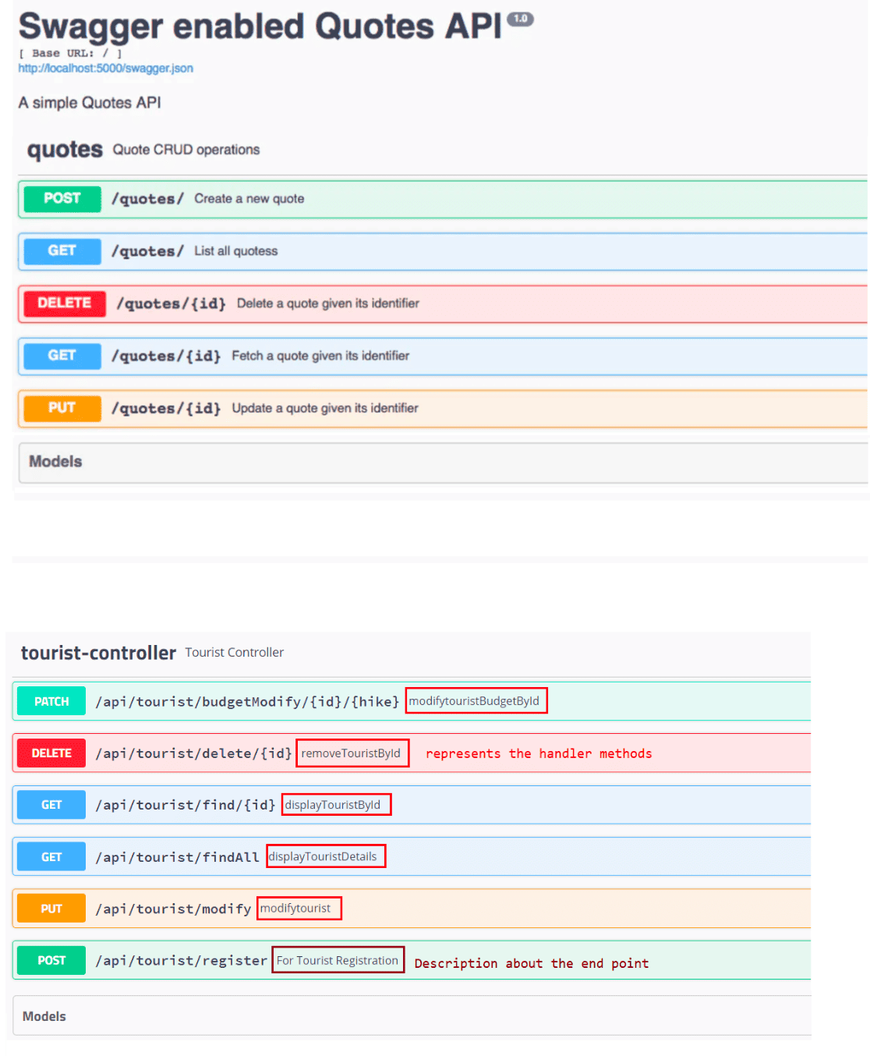
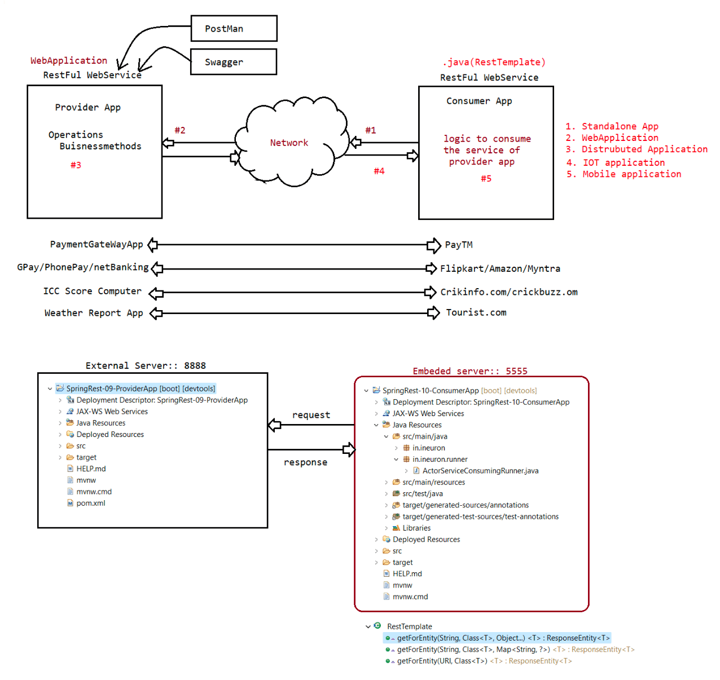

197 SpringRest using WebClient,sending both synchronous and nonsynchronous request in both GET and POST mode, working with hateos feature.

Working with RestTemplate
=========================
Methods associated with RestTemplate
xxxForEntity(,,,) => overloaded method
Instead of calling xxxForEntity as per the requeset methods we can use single
exchange(,,) for all operations
Note:: @RequestMapping(value="" method = RequestMethod.POST/GET)
or
@GetMapping(value="") and @PostMapping(value="")
Syntax of exchange()
====================
public <T> ResponseEntity<T> exchange(
String url,
HttpMethod method,
HttpEntity<?> requestEntity,
Class<T> responseType,
Object... uriVariables)throws
RestClientException
url => The URL
method => HttpMethod(GET,POST,...)
requestEntity => headers+body
responseType => required response type
urivairables => path variable values
Output:: ResponsEntity<T>
Note: This method is an alternative to getForEntity(), postForEntity(),......
RestTemplate supports synchronous communication.
RestTemplate introduced in Spring3.X version
Internally RestTemplate uses java.net connection to send HttpRequest
WebClient
=========
It is introduced from Spring5.X
It supports for both Synchronous and Asynchronous request
To use WebClient,SpringBoot has provided a starter called "SpringWebFlux".
<dependency>
<groupId>org.springframework.boot</groupId>
<artifactId>spring-boot-starter-webflux</artifactId>
</dependency>
Code
=====
@Service("service")
public class CurrencyService {
private static final String REST_END_POINT =
"http://localhost:8888/SpringRest-CurrencyConverter-Providerapp/api/
currency/getCurrencyExchangeCost/from/USD/to/INR";public void invokeRestApiSync(String from, String to) {
// Sending Synchronous request
WebClient webClient = WebClient.create();
System.out.println("***Synchronous: Rescall started ******");
CurrencyResponse response = webClient.
get().
uri(REST_END_POINT, from, to).
accept(MediaType.APPLICATION_JSON).
retrieve().
bodyToMono(CurrencyResponse.class).
block();
System.out.println(response);
System.out.println("****Synchronous: Restcall ended ******");
}
public void invokeRestApiASync(String from, String to) {
// Sending Synchronous request
WebClient webClient = WebClient.create();
System.out.println("***ASynchronous: Restcall started ******");
webClient.
get().
uri(REST_END_POINT, from, to).
accept(MediaType.APPLICATION_JSON).
retrieve().
bodyToMono(CurrencyResponse.class).
subscribe(CurrencyService::myResponse);
System.out.println("****ASynchronous: Restcall ended ******");
}
public static void myResponse(CurrencyResponse response) {
System.out.println(response);
//use repsonse object as per the needs[push to Apache-kafka]
}
}
refer:: SpringRest-CurrencyConverter-Providerapp and SpringRest-
WebClient-GetRequest
Sending POST request
====================
@Service("service")
public class ERailClientApp {
private static final String REST_END_URL = "http://localhost:8888/SpringRest-
TicketBooking-ProviderApp/api/ticket/register";
public void invokeRestApi() {
WebClient client = WebClient.create();
PassengerInfo body = new PassengerInfo();
body.setFirstName("nitin");
body.setLastName("manjunath");
body.setJourneyDate("22/06/2023");body.setFrom("bengaluru");
body.setTo("pune");
body.setTrainNumber("BNG-PUN-1234");
Ticket response =
client.post().uri(REST_END_URL).accept(MediaType.APPLICATION_JSON)
.body(BodyInserters.fromValue(body)).retrieve().bodyToMono(
Ticket.class).block();
System.out.println(response);
}
}
refer::SpringRest-TicketBooking-ProviderApp and SpringRest-
WebClient-PostRequest
Develop a REST API with HATEOAS
==============================
1. SpringBoot has provided a starter file to work with HATEOS
eg: <dependency>
<groupId>org.springframework.boot</groupId>
<artifactId>spring-boot-starter-hateoas</artifactId>
</dependency>
eg#1
@Data
@AllArgsConstructor
@NoArgsConstructor
public class Book extends RepresentationModel {
private String isbn;
private String name;
private Double price;
private String author;
}
RestController
=============
public class BookController {
@GetMapping(value = "/getBook/{isbn}", produces = "application/json")
public ResponseEntity<Book> getBook(@PathVariable("isbn") String isbn) {
Book book = new Book(isbn, "Spring", 234.5, "RodJhonson");
Link link =
WebMvcLinkBuilder.linkTo(WebMvcLinkBuilder.methodOn(BookController.class).getAllBoo
ks())
.withRel("allBooks");
book.add(link);
return new ResponseEntity<Book>(book, HttpStatus.OK);
}
@GetMapping(value = "/allBooks")public List<Book> getAllBooks() {
List<Book> bookList = new ArrayList<Book>();
bookList.add(new Book("ISBN-111", "Spring", 350.5, "RodJhonson"));
bookList.add(new Book("ISBN-222", "Hibernate", 350.5, "GavinKing"));
bookList.add(new Book("ISBN-333", "Servlet", 350.5, "KeitySeirra"));
return bookList;
}
}
Input: http://localhost:9999/getBook/10
Output:
{
"isbn": "10",
"name": "Spring",
"price": 234.5,
"author": "RodJhonson",
"_links": {
"allBooks": {
"href": "http://localhost:9999/allBooks"
}
}
}
.
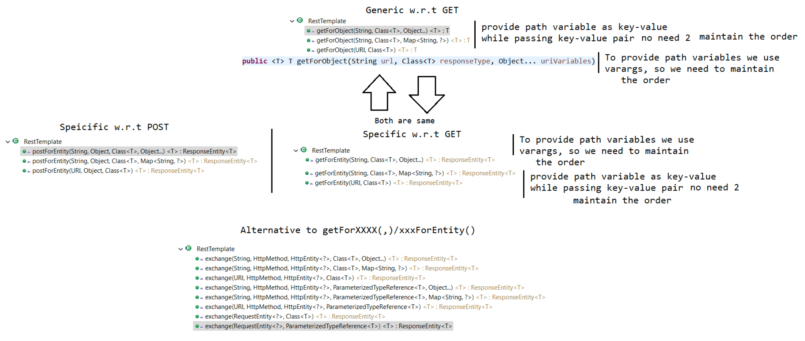
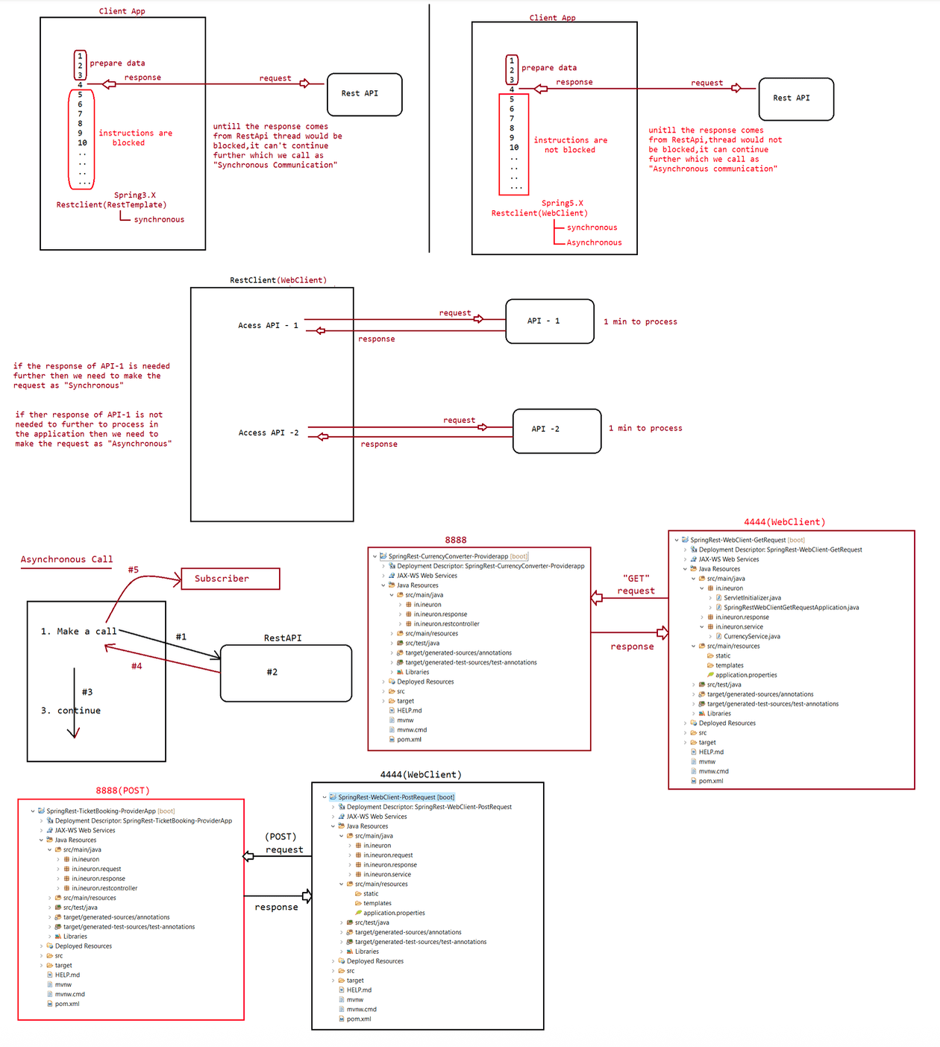
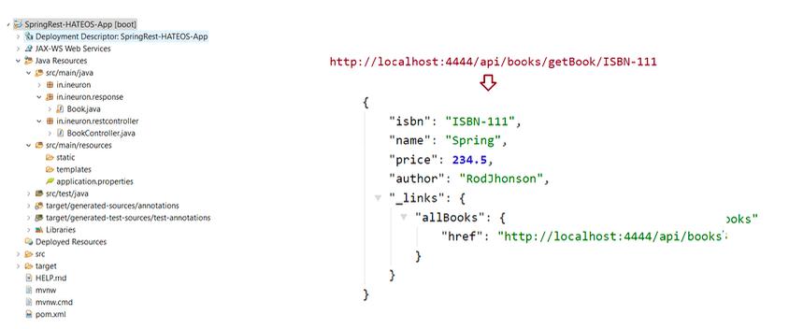

198 Usage of SpringAOP in realtime application, working with @Around and working with @annotation.. Usage of runners and differnt types of runners with example

Revise the following concepts
=============================
Ananomyous inner class, lambda expression, method reference
Annotation support in AOP
=========================
1. @Aspect
2. @After
3. @Before
4. @Around
5. @AfterReturning
6. @AfterThrowing
7. @Pointcut
JoinPoint => Combination of Advice + PointCut
@Around => It would be used combination of @After and @Before
ProceedingJoinPoint => This interface help us to make a call to buisness
method(need to be called using proceed())
Eg#1.
@Component
public class EmployeeDao {
public Integer saveEmployee() { //#3
System.out.println("Employee Object is saved...");
return 10;
}
}
@Pointcut("execution(public * in.ineuron.dao.EmployeeDao.*())")
public void p1() {}
@Around("p1()")
public void aroundAdvice(ProceedingJoinPoint jp) {
System.out.println("Before Transaction"); // #1
try {
Object object = jp.proceed(); // #2
System.out.println("DATA IS :: "+object);
} catch (Throwable e) {
e.printStackTrace();
}
System.out.println("After Transaction"); #4
}
@Component
public class Employeerunner implements CommandLineRunner {
@Autowired
private EmployeeDao dao;
@Override // main---->employeeRunner.run() -----> continue with buisnesslogic
public void run(String... args) throws Exception {
dao.saveEmployee();
}
}
@SpringBootApplication
public class SpringAopAspectJAppApplication {
public static void main(String[] args) {
SpringApplication.run(SpringAopAspectJAppApplication.class, args);
}
}
Output
======
Before Transaction
Employee Object is saved...
DATA IS :: 10
After Transaction
refer:: Spring-AOP-AspectJApp
Application of AOP
=================
public interface IEmployeeService{
public int saveEmployee(Employee employee);
}
@Service("empService")
public class EmployeeServiceImpl implements IEmployeeService{
@Autowired
private IEmployeeDao dao;
@Transactional // Real Time usage of AOP
public int saveEmployee(Employee employee){
dao.save(Employee); // internally jpa--->
Hibernate[BeforeTransaction,....,AfterTransaction]
}
}
}
public interface IEmployeeDao implements JpaRepository<Employee,Integer>{
@Repository
@Transactional(readOnly = true)
public class SimpleJpaRepository<T, ID> implements JpaRepositoryImpl<T,ID>{
@Transactional
@Override
public <S extends T> S save(S entity) {
Assert.notNull(entity, "Entity must not be null.");
if (entityInformation.isNew(entity)) {
em.persist(entity); //save operationreturn entity;
} else {
return em.merge(entity);//update operation
}
}
}
Another application is SpringRest-GlobalException Handler[@RestControllerAdvice]
================================================================================
@RestController
@RequestMapping("/api/ticket")
public class TicketRestController{
@GetMapping("/find/{id}")
public ResponseEntity<Ticket> findById(@Pathvariable Integer id){
//if exception is recieved from Service<----Dao
}
}
@RestController
@RequestMapping("/api/student")
public class StudentRestController{
@GetMapping("/find/{id}")
public ResponseEntity<Student> findById(@Pathvariable Integer id){
//if exception is recieved from Service<----Dao
}
}
@RestController
@RequestMapping("/api/employee")
public class EmployeeRestController{
@GetMapping("/find/{id}")
public ResponseEntity<Employee> findById(@Pathvariable Integer id){
//if exception is recieved from Service<----Dao
}
}
@RestControllerAdvice
public class GlobalExceptionHandlerAdvice{
@ExceptionHandler(TicketNotfoundException.class)
public ResponseEntity<ErrorDetails>
handleTicketNotFoundException(TicketNotFoundException te){
;;;;;
}
@ExceptionHandler(EmployeeNotFoundException.class)
public ResponseEntity<ErrorDetails>
EmployeeNotFoundException(EmployeeNotfoundException ef){
;;;;;
}
@ExceptionHandler(StudentNotFoundException.class)
public
ResponseEntity<ErrorDetails>StudentNotFoundException(StudentNotFoundException sf){
;;;;;
}@ExceptionHandler(Exception.class)
public ResponseEntity<ErrorDetails> handleOtherException(Exception e){
;;;;;
}
}
Usage of custom annotation to support AOP
=========================================
@Aspect
@Component
public class TransactionManagement {
@Pointcut("@annotation(in.ineuron.annotation.MyTransaction)")
public void p1() {
}
@Before("p1()")
public void beforeTransaction() {
System.out.println("***Before Transaction ***");
}
@After("p1()")
public void afterTransaction() {
System.out.println("***After Transaction ***");
}
}
@Retention(RUNTIME) //It indicates where the effect of annotation should be
available.
@Target(METHOD) //It indicates where this annotation can be used in
code[class/Field/Method].
public @interface MyTransaction {
}
EmployeeDao.java
================
@Component
public class EmployeeDao {
@MyTransaction
public void saveEmployee() {
System.out.println("Employee Object is saved...");
}
}
Output
***Before Transaction ***
Employee Object is saved...
***After Transaction ***
refer:: Spring-AOP-AspectJApp2
Runners in SpringBoot
=====================
=> Runners java classes cum springbeans of Springboot app implementingxxxRunner(I) directly or indirectly.
=> EveryRunner class contains run()dealing with one time execution logic and these
logics will execute where SpringApplication.run() is about to complete
all its startup activities[Right after Creating ApplicationContext object and
Completing Pre-Instantiation and Injections].
=> The run() of every Runner class will be executed automatically by IOC container
only for one time as a part of Application startup process
that takes place in SpringApplication.run() method.
Two types of Runners in SpringBoot
==================================
1. CommandLineRunner(I)[1.0V]
2. ApplicationRunner(I)[1.3V]
What is the difference b/w CommandLineRunner and ApplicationRunner?
Both the runners are giving run() as the callback method(Becoz it will be called
by underlying IOC container automatically)
Both the runners run() method get command line args(programs args) as the
parameter values,but the way they get them is different.
CommandLineRunner(I)
|=> public void run(String... args)
ApplicationRunner(I)
|=> public void run(ApplicationArguments args)
What is the usage of Runners in SpringBoot Apps?
=> Executing the dbscripts and keeping table with row ready
=> Perform some testing activities related to AutoConfiguration and its
injections.
=> Logging activities related to AutoConfiguration and startup activities
=> To send email or sms alter messages to admin when imp services started during
the startup process
of Spring Boot application,start of server, initialization of buisness
methods,smsgateway,payement gateway
=> Though there are multiple modules in Project, if u want to activate only
certain modules we can take the support of Runners
=> To create dummy/admin email ids,dummy or admin accounts during the startup
process automaticlly we take support of Runners.
Note: In realtime project the main class(Configuration class main class that
contains @SpringBootApplication) main() method contains
only SpringApplication.run() method call.
The remaining logics like getting SpringBean class object IOC container,
invoking b.method and etc ...
Now this logic can be done from run() of runner class through various
injections.
public class SpringApplication{
public ConfigurableApplicationContext run(String... args) {
long startTime = System.nanoTime();
DefaultBootstrapContext bootstrapContext = createBootstrapContext();
ConfigurableApplicationContext context = null;
configureHeadlessProperty();
SpringApplicationRunListeners listeners = getRunListeners(args);listeners.starting(bootstrapContext, this.mainApplicationClass);
try {
ApplicationArguments applicationArguments = new
DefaultApplicationArguments(args);
ConfigurableEnvironment environment =
prepareEnvironment(listeners, bootstrapContext, applicationArguments);
configureIgnoreBeanInfo(environment);
Banner printedBanner = printBanner(environment);
context = createApplicationContext();
context.setApplicationStartup(this.applicationStartup);
prepareContext(bootstrapContext, context, environment, listeners,
applicationArguments, printedBanner);
refreshContext(context);
afterRefresh(context, applicationArguments);
Duration timeTakenToStartup = Duration.ofNanos(System.nanoTime()
- startTime);
if (this.logStartupInfo) {
new
StartupInfoLogger(this.mainApplicationClass).logStarted(getApplicationLog(),
timeTakenToStartup);
}
listeners.started(context, timeTakenToStartup);
callRunners(context, applicationArguments);
}
catch (Throwable ex) {
handleRunFailure(context, ex, listeners);
throw new IllegalStateException(ex);
}
try {
startTime);
Duration timeTakenToReady = Duration.ofNanos(System.nanoTime() -
listeners.ready(context, timeTakenToReady);
}
catch (Throwable ex) {
handleRunFailure(context, ex, null);
throw new IllegalStateException(ex);
}
return context;
}
}
Note:: We can have multiple runners in our project, if mulitple runners are
available then based on Alphabetical order of
class names the runners will run.
If we want a particular runner to run then we need to use @Order.
Syntax :: @Order(any-no)
In case of Commandline arguments the data will be stored in the form of String[]
Commandline Arguments :: [START, LOAD, END]
refer:: SpringBoot-Runner-01
Note::
@FunctionalInterface
public interface ApplicationRunner {void run(ApplicationArguments args) throws Exception;
@FunctionalInterface
public interface CommandLineRunner {
void run(String... args) throws Exception;
}
}

199 SpringBoot Runner(ApplicationRunner vs CommandLineRunner) example, Creating customzied Banner,Working with SpringMAIL

Runners
=> CommandLineRunner(I)[1.0V]
=> ApplicationRunner(I)[1.3V]
The difference b/w the above 2 runners is they vary in the way the arguments are
collected.
ApplicationArguments
====================
1. Option Arguments(inputs)
--key = val
2. Non Option Arguments(commands)
start
close
data
execute
dump
stop
Difference b/w CLR and APR?
Ans. Working process same, only difference is in inputs.
CLR reads inputs from main() and stores as ArrayFormat(String[])
ALR reads inputs from main() and converts into Option(--key=value) and Non-
Option(only value) args and given to AR.
Note: ApplicationRunner can be used to override the value which are coming from
application.properties file aslo.
CommandLineRunner
=================
@FunctionalInterface
public interface CommandLineRunner {
void run(String... args) throws Exception;
}
++++++++++++++++++++++++++++++++++++++++++++++++++
SourceCode1::
@Configuration
public class AppConfig {
@Bean
public CommandLineRunner runA() {
// syntax:: new CommandLineRunner(){....}
return new CommandLineRunner() {
@Override
public void run(String... args) throws Exception {
System.out.println("HELLO :: " + Arrays.asList(args));
}
};
}
}
SoureCode::2
@Configuration
public class AppConfig {
@Bean
public CommandLineRunner runA() {
// Syntax:: Interface obj =(params)->{MethodBody;}return (args) -> {
System.out.println("FROM RUNNER :: " + Arrays.asList(args));
};
}
}
SourceCode:: 3
@Configuration
public class AppConfig {
@Bean
public CommandLineRunner runA() {
//Syntax=> ClassName :: methodName
return SampleTest::test;
}
}
public class SampleTest {
public static void test(String... args) {
System.out.println("FROM METHOD REF:: " + Arrays.asList(args));
}
}
refer:: SpringBoot-Runner-02,SpringBoot-Runner-03
Adding Custom banner to SpringBoot application
==============================================
public ConfigurableApplicationContext run(String... args) {
long startTime = System.nanoTime();
DefaultBootstrapContext bootstrapContext = createBootstrapContext();
ConfigurableApplicationContext context = null;
configureHeadlessProperty();
SpringApplicationRunListeners listeners = getRunListeners(args);
listeners.starting(bootstrapContext, this.mainApplicationClass);
try {
ApplicationArguments applicationArguments = new
DefaultApplicationArguments(args);
ConfigurableEnvironment environment =
prepareEnvironment(listeners, bootstrapContext, applicationArguments);
configureIgnoreBeanInfo(environment);
//Banner is getting generated
Banner printedBanner = printBanner(environment);
context = createApplicationContext();
context.setApplicationStartup(this.applicationStartup);
prepareContext(bootstrapContext, context, environment, listeners,
applicationArguments, printedBanner);
refreshContext(context);
afterRefresh(context, applicationArguments);
Duration timeTakenToStartup = Duration.ofNanos(System.nanoTime()
- startTime);
if (this.logStartupInfo) {
new
StartupInfoLogger(this.mainApplicationClass).logStarted(getApplicationLog(),
timeTakenToStartup);
}listeners.started(context, timeTakenToStartup);
callRunners(context, applicationArguments);
}
catch (Throwable ex) {
handleRunFailure(context, ex, listeners);
throw new IllegalStateException(ex);
}
try {
startTime);
Duration timeTakenToReady = Duration.ofNanos(System.nanoTime() -
listeners.ready(context, timeTakenToReady);
}
catch (Throwable ex) {
handleRunFailure(context, ex, null);
throw new IllegalStateException(ex);
}
return context;
}
Creating our OwnBaner in Programmatic Approach
==============================================
@FunctionalInterface
public interface Banner {
/**
* Print the banner to the specified print stream.
* @param environment the spring environment
* @param sourceClass the source class for the application
* @param out the output print stream
*/
void printBanner(Environment environment, Class<?> sourceClass, PrintStream
out);
}
Making the Banner to display while booting the Application
==========================================================
enum Mode {
/**
*/
OFF,
* Disable printing of the banner.
/**
*/
CONSOLE,
* Print the banner to System.out.
/**
*/
LOG
* Print the banner to the log file.
}
Step1::
src/main/java|=> in.ineuron.banner
|=> banner.txt
banner.txt
===========
__ __ __ ____ __ __ ____ ___ __ __
|| ||\ || || || || || \\ // \\ ||\ ||
|| ||\\|| ||== || || ||_// (( )) ||\\||
|| || \|| ||___ \\_// || \\ \\_// || \||
Step2::
application.properties
======================
spring.main.banner-mode=console
spring.banner.location=classpath:in/ineuron/banner/banner.txt
Step3::
@SpringBootApplication
public class SpringBootBannerAppApplication {
@SuppressWarnings("static-access")
public static void main(String[] args) {
SpringApplication application = new SpringApplication();
ConfigurableApplicationContext ctx =
application.run(SpringBootBannerAppApplication.class, args);
ctx.close();
}
}
Step4:: Run the application and check the banner in console.
Working with SpringBoot-Mail
===========================
1. Add the following dependancies
<dependency>
<groupId>org.springframework.boot</groupId>
<artifactId>spring-boot-starter-mail</artifactId>
</dependency>
2. Required Bean JavaMailSender will be autoconfigured
3. Create a Service class
public interface IPurchaseOrder {
public String purchase(String[] items,double [] prices,String[] toEmails)
throws Exception;
}
@Service("service")
public class PurchaseOrderImpl implements IPurchaseOrder {
@Autowired
private JavaMailSender sender;@Value("${spring.mail.username}")
private String fromEmail;
@Override
throws Exception {
public String purchase(String[] items, double[] prices, String[] toEmails)
double amt = 0.0;
for (double price : prices) {
amt = amt + price;
}
Arrays.toString(prices)
String msg = Arrays.toString(items) + "with price :: " +
+ " are purchase with billamout :: " + amt;
String status = sendMail(msg, toEmails);
return msg + "---> " + status;
}
private String sendMail(String msg, String[] toEmails) throws Exception {
System.out.println("Sender implementation class is :: " +
sender.getClass().getName());
MimeMessage message = sender.createMimeMessage();
MimeMessageHelper helper = new MimeMessageHelper(message, true);
helper.setFrom(fromEmail);
helper.setCc(toEmails);
helper.setSubject("Open it to konw it");
helper.setSentDate(new Date());
helper.setText(msg);
helper.addAttachment("ineuron.jpg", new
ClassPathResource("ineuron.jpg"));
sender.send(message);
return "mail-sent";
}
}
4. Set up application.properties
#Properties to tell the mail protocol vendor
spring.mail.host=smtp.gmail.com
spring.mail.port=587
#Actual username,password of sender
spring.mail.username=setusername
spring.mail.password=setpassword
#Property to trigger smtp
spring.mail.properties.mail.smtp.auth=false
spring.mail.properties.mail.smtp.starttls.enable=true
spring.mail.properties.mail.smtp.starttls.required = true
5. Build main app and run the application@SpringBootApplication
public class SpringBootMailAppApplication {
public static void main(String[] args) {
ApplicationContext context =
SpringApplication.run(SpringBootMailAppApplication.class, args);
IPurchaseOrder order = context.getBean(IPurchaseOrder.class);
try {
String msg = order.purchase(new String[] { "Fossil-Chronography",
"USPOLO-Tshirt", "LouisPhilippe-Shoes" },
new double[] { 12000.0, 5000.0, 6000.0 }, new
String[] { "attrayaghoshdas@gmail.com",
"nithinvanga01@gmail.com",
"nilesh7345kaka@gmail.com" });
System.out.println(msg);
} catch (Exception e) {
e.printStackTrace();
}
((ConfigurableApplicationContext) context).close();
}
}
Note: Before running app
a. login to sender email account(like gmail login),go to account letter/image
b. go to manage settings -> security -> change less secure apps access to ON
Evening :: All the remaining topics of DataJpA(H2,postgresql,workign with mulitple
database,Association)
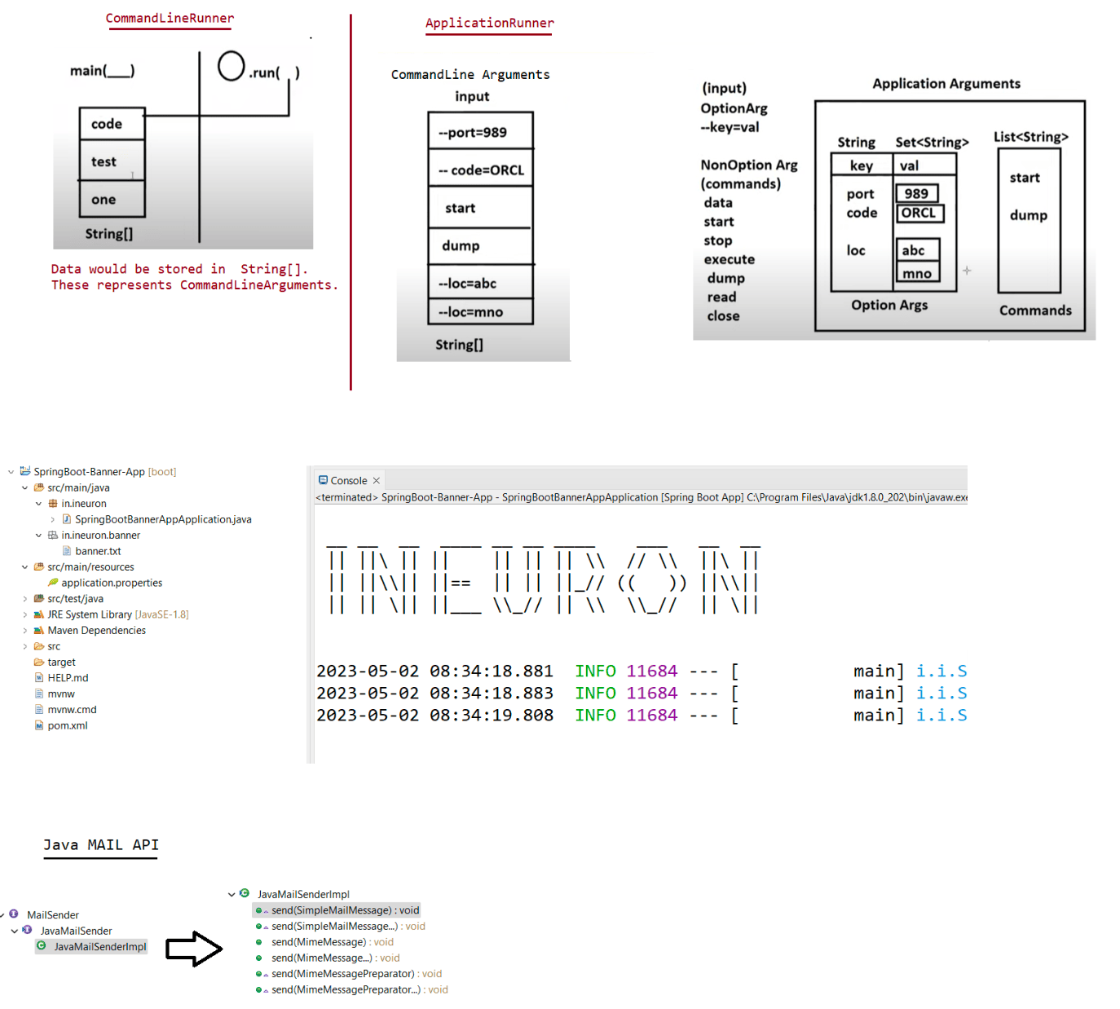

200 SpringDataJpa using Embeded database(H2) and Working with Postgresql[Testing them using SpringRest]

Fresher(Upto 2 years)
=====================
1. SpringBoot
a. SpringCore basics
b. SpringJDBC
c. SpringORM
d. SpringDataJPa
e. SpringMVC
f. SpringAOP
2+ years of Experience
1. SpringBoot
2. SpringRest and Microservices
3. Design patterns and basics of Cloud
DataJpa Pending topics
======================
1. Working with Embeded Database
2. Working with Postgresql Database
3. Working with Mulitple database
4. Association
5. SpringMail
Embeded :: By default it would be a part of software.
Embeded Database :: When running the application(In JRE it would available)
Once the application stops then Database Memory would be
taken away from JRE.
For POC(Proof of Concept) by default SpringBoot supports a database called "H2".
Working with EmbededDatabase[Default port is the port which is used for running
applications]
==========
===================================================================================
Create a dependancy with H2,Lombok,Datajpa,SpringWeb
1. To work with Embeded Database we need to use the following dependancy in pom.xml
file
<dependency>
<groupId>com.h2database</groupId>
<artifactId>h2</artifactId>
<scope>runtime</scope>
</dependency>
2. application.properites
#Details about H2 database
spring.datasource.driverClassName=org.h2.Driver
spring.datasource.url=jdbc:h2:mem:ineurondb
spring.datasource.username=sa
spring.datasource.password=
#Displaying the query details on console
spring.jpa.show-sql=true
spring.jpa.hibernate.ddl-auto=update
spring.jpa.properties.hibernate.format_sql=true#Dialect information of h2 database
spring.jpa.database-platform=org.hibernate.dialect.H2Dialect
#enabling the H2 console
spring.h2.console.enabled=true
#Server port to host our application and same port will be used for H2-Database
also
server.port=4444
3. Model(Student)[id,name,email,address]
4. in.ineuron.restcontroller
[Endpoints
a. POST => /register
b. GET => /student/findAll,
c. GET => /student/find/{id} ,
d. PUT => /register
e. DELETE => /student/{id}
]
5. run the application and test the h2 database in the following url
http://localhost:4444/h2-console
refer:: SpringRest-H2-Database-App
Working with PostgreSQL[Portno:: 5432]
======================
Download and install postgresql from the following link
https://www.enterprisedb.com/downloads/postgres-postgresql-downloads
1. Create a project with the following starter files
datajpa,web,postgresql driver
pom.xml
=======
<dependency>
<groupId>org.postgresql</groupId>
<artifactId>postgresql</artifactId>
<scope>runtime</scope>
</dependency>
2. Create application.properties
#Driver url,username,password
spring.datasource.dbcp2.driver-class-name= org.postgresql.Driver
spring.datasource.url=jdbc:postgresql://localhost:5432/ineuronDb
spring.datasource.username=postgres
spring.datasource.password=root123
## Hibernate Properties
# The SQL dialect makes Hibernate generate better SQL for the chosen database
spring.jpa.properties.hibernate.dialect = org.hibernate.dialect.PostgreSQLDialect
spring.jpa.show-sql=true
spring.jpa.properties.hibernate.format_sql=true
# Hibernate ddl auto (create, create-drop, validate, update)
spring.jpa.hibernate.ddl-auto = update#Server port to host our application and same port will be used for H2-Database
also
server.port=4444
3. To open postgresql just pgadmin4 and type password of the dbadmin to open.
4. Run the application and test in postman client
refer:: SpringRest-PostgreSQL-App
